**CHOCOLATE FLAVOURS ANALYSIS**

**INTRODUCTION**

Chocolate is one of the most popular candies in the world. Each year, residents of the United States collectively eat more than 2.8 billion pounds. However, not all chocolate bars are created equal.

This dataset contains expert ratings of over 1,700 individual chocolate bars, along with information on their regional origin, percentage of cocoa, the variety of chocolate bean used and where the beans were grown.

**QUESTIONS**

* • Where is the best cocoa bean grown?
* • Which country produced the highest rated bar?
* • What is the relationship between cocoa solid percentage and rating?

**DATA CLEANING PROCESS**

* **I** imported and cleaned the data with Microsoft Excel.
* I cross checked and changed spelling errors in every column in the data set.
* I rearranged and corrected spellings in the column headers.
* I checked and removed every duplicates in the data set.
* I replaced the empty spaces with null values .
* i created a Chocolate Flavour Rating System using the **IFS** statement. This helped me to classify the cocoa percentage into 6 categories (Elite = 5, Premium = 4, Satisfactory = 3.75, Praiseworthy = 3, Disappointing = 2,Unpleasant = 1)

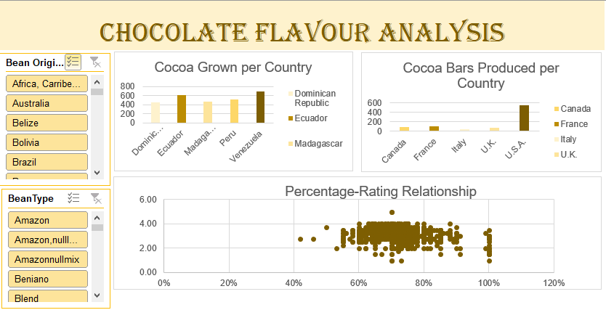

**ANSWERS**

1. The best cocoa beans were grown in VENUZUELA
2. USA produced the highest rated cocoa bars
3. There was no correlation between the Cocoa Flavour ratings and the Cocoa Percentage